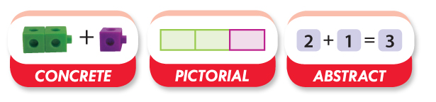
Measham C of E Primary School
Calculation Guide

Division
A guide for parents and carers on the methods used in school

Rationale
Mathematics is all around us; it underpins much of our daily lives and our futures as individuals and collectively. As the Secretary of State for Education said last year:
‘… mathematical understanding is critical to our children's future. Our economic future depends on stimulating innovation, developing technological breakthroughs, making connections between scientific disciplines. And none of that is possible without ensuring more and more of our young people are mathematically literate and mathematically confident. Mathematical understanding underpins science and engineering, and it is the foundation of technological and economic progress. As information technology, computer science, modelling and simulation become integral to an ever-increasing group of industries, the importance of maths grows and grows.’
It is therefore of fundamental importance to ensure that children have the best possible grounding in mathematics during their primary years.

Year 1
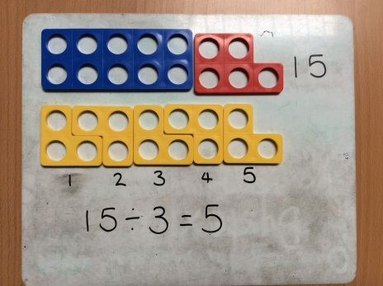
I can use Numicon to show ‘sharing’
15÷3
How many 3’s in 15?
15 shared between 3

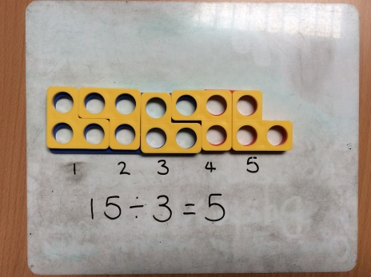

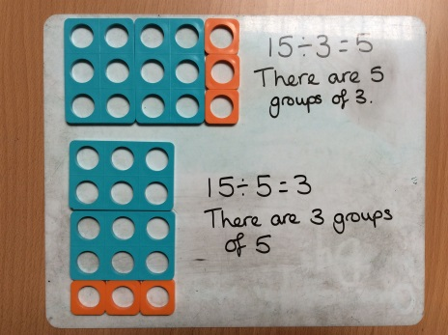
I can use arrays to show that
15÷3=5 is related to
15÷5=3

Mental Strategies
- I can count on and back, in steps of 2,5 and 10.
- I can recognise the relationship between division and multiplication
- I can understand division as sharing and grouping

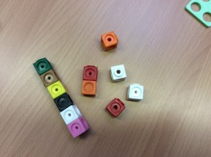
Equipment
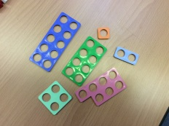
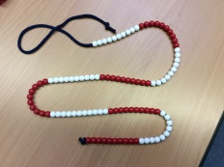

Key Vocabulary
Sharing, groups of, lots of, doubling, halving, divide

Example of Key Questions
How else could 20 sweets be put into bags so that every bag had the same number of sweets?
How many bags would be packed each time?
Year 2
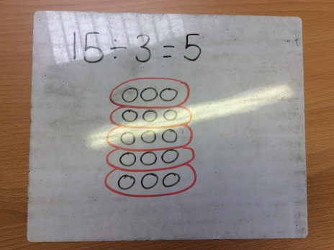
I can use arrays to help me solve division questions.

I can solve division by grouping together

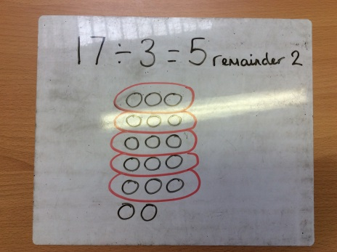
I can also use arrays to show division with remainders
.

Mental Strategies
- I can count on and back, in steps of 2,3,5 and 10.
- Children who can count in 2,3,5,10s can use this knowledge to work out other facts such as 2x6, 5x4, 10x9.
- I can hold out my fingers to support for example - ‘How many 3’s are in 18?’
Equipment

Key Vocabulary
Group in pairs, 3s … 10s etc, equal groups of, divide, divided by, divided into, remainder, ÷

Example of Key Questions
Two friends want to buy some marbles and then share them out equally between them.
They could buy a bag of 13 marbles, a bag of 14 marbles or a bag of 19 marbles?What size bag should they buy so that they can share them equally?
What other numbers of marbles could be shared equally?
Explain your reasoning.

Year 3

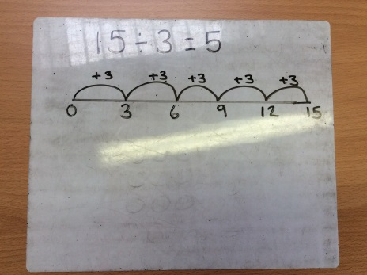
I can use number lines and my multiplication tables to show grouping of numbers

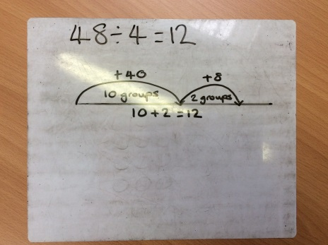

I can partition a number in different ways to help with my division

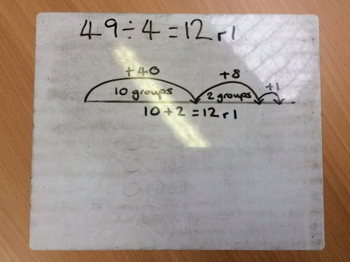
I can divide numbers on a number line that will have a remainder

Mental Strategies
- I can count on and back, in steps of 3,4,8.
- I can use multiplication faxts to make links with other facts e..g 3x2=6, 30x2=60, 6÷3=2, 60÷3=20
- I can begin to make links between division and fractions e.g. 3 apples shared between 4 people = ¾

Equipment

Key Vocabulary
Group in pairs, 3s … 10s etc, equal groups of, divide, divided by, divided into, remainder, ÷, inverse

Example of Key Questions
The following problems can be solved by using the calculation 8 ÷ 2. True or false?
There are 2 bags of bread rolls that have 8 rolls in each bag. How many rolls are there altogether?
A boat holds 2 people. How many boats are needed for 8 people?
I have 8 pencils and give 2 pencils to each person. How many people receive pencils?
I have 8 pencils and give 2 away. How many do I have left?

Year 4

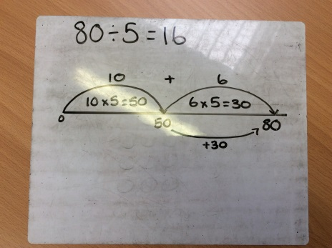
I can use number lines and my knowledge of tables to solve division

I can find 10x first then work out how many is left.

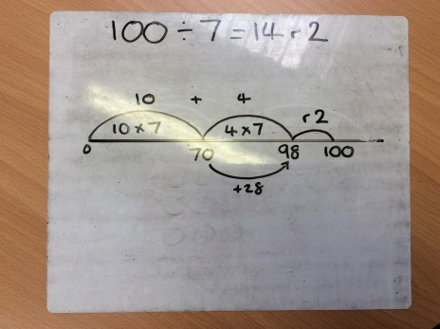
I can use numbers that have a remainder

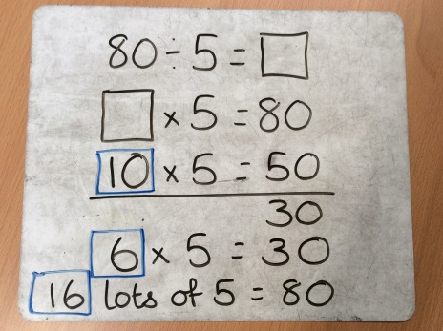

I can begin to use chunking once I am secure on a numberline

Mental Strategies
- I can count on and back, from different numbers in multiples of 4,6,7,8,9,25, and 1000.
- I can become fluent in the recall of all tables to x12

Equipment

Key Vocabulary
Group in pairs, 3s … 10s etc, equal groups of, divide, divided by, divided into, remainder, ÷, inverse, divisible by, divided into, share between, factor, factor pair, equals, quotient, divisor

Example of Key Questions
Mrs Carpenter says, ‘To find a tenth of a number I divide by 10 and to find a fifth of a number I divide by 5’.
Do you agree?
Explain your reasoning.

Year 5

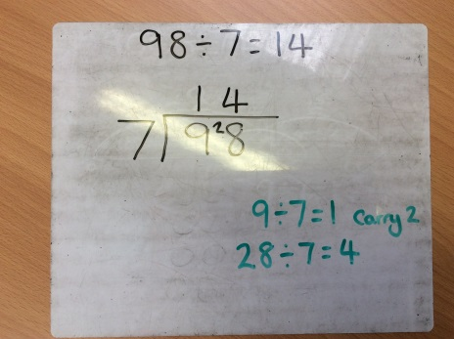
I can use the short division (bus stop) method to solve division

I can also use the short division (bus stop) method to solve division with remainders

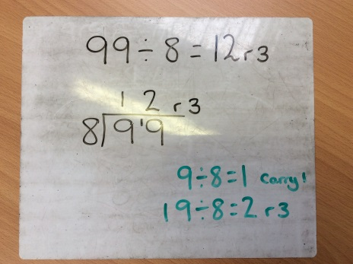

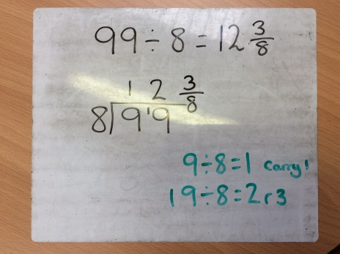
I can then use the short division (bus stop) method to solve division with remainders and turn these into fractions

Mental Strategies
- I can regularly using a range of multiples and powers of 10,100,1000
- I can practise and apply the multiplication facts to x12 and the inverse
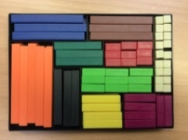
Equipment

Key Vocabulary
Group in pairs, 3s … 10s etc, equal groups of, divide, divided by, divided into, remainder, ÷, inverse, divisible by, divided into, share between, factor, factor pair, equals, quotient, divisor, common factors, prime number, prime factors, short division, square number, cube number, power of

Example of Key Questions
Fill in the missing numbers
÷120 = 117 ÷ 13 = 10,800 ÷ = 234 ÷

Year 6
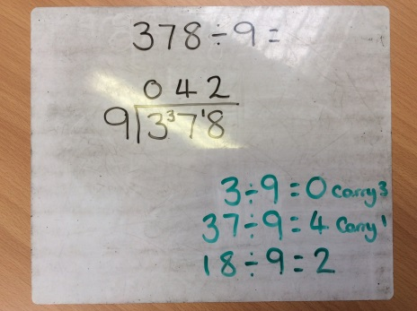

I can use the short division (bus stop) method to solve division with remainders as fractions

I can then move to dividing by 2 digits

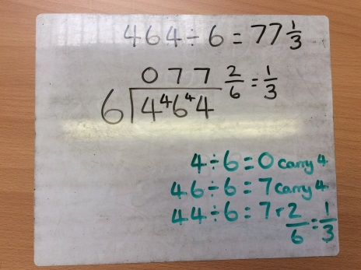

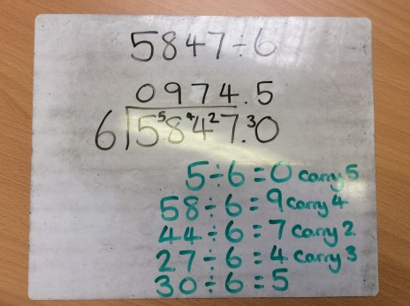

I can use the short division (bus stop) method to solve division with remainders as decimals

Mental Strategies
- I can regularly using a range of multiples and powers of 10,100,1000
- I can practise and apply the multiplication facts to x12
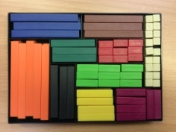
Equipment

Key Vocabulary
Group in pairs, 3s … 10s etc, equal groups of, divide, divided by, divided into, remainder, ÷, inverse, divisible by, divided into, share between, factor, factor pair, equals, quotient, divisor, common factors, prime number, prime factors, short division, square number, cube number, power of, fraction

Example of Key Questions
In each pair of calculations, which one would you prefer to work out?

(a) 35 × 0·3 + 35 × 0·7 or (b) 3·5 × 0·3 + 35 × 7
c) 6·4 × 1·27 – 64 × 0·1 or (d) 6·4 × 1·27 – 64 × 0·027
(e) 52·4 ÷ 0·7 + 524 ÷ 7 or (f ) 52·4 ÷ 0·7 – 524 ÷ 7
(g) 31·2 ÷ 3 – 2·4 ÷ 6 or (h) 31·2 ÷ 3 – 1·2 ÷ 0·3
Explain your choices.

