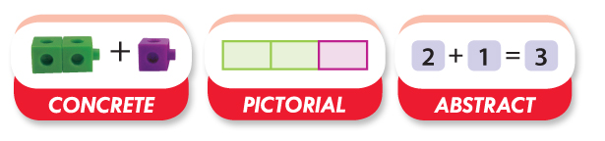
Measham C of E Primary School
Calculation Guide

EYFS
A guide for parents and carers on the methods used in school

Rationale
Research on children’s learning in the first six years of life demonstrates the importance of early experiences in mathematics. An engaging and encouraging climate for children’s early encounters with mathematics develops their confidence in their ability to understand and use mathematics. These positive experiences help children to develop dispositions such as curiosity, imagination, flexibility, inventiveness, and persistence, which contribute to their future success in and out of school (Clements & Conference Working Group, 2004).
The NCTM (National Council of Teachers of Mathematics) states “Young learners’ future understanding of mathematics requires an early foundation based on a high-quality, challenging, and accessible mathematics education. Young children in every setting should experience mathematics through effective, research-based curricula and teaching practices. Such practices in turn require that teachers have the support of policies and resources that enable them to succeed in this challenging and important work.”
Mathematics involves providing children with opportunities to develop and improve their skills in counting, understanding and using numbers, calculating simple addition and subtraction problems; and to describe shapes, spaces, and measures. (Statutory Framework for the Early Years Foundation Stage, DfE: 2012)
Addition
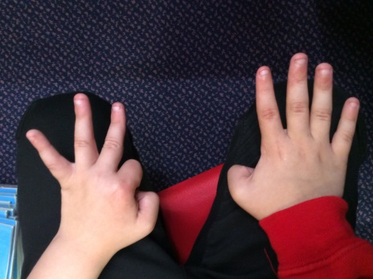
I can solve simple problems using fingers

I can use Numicon to add numbers together

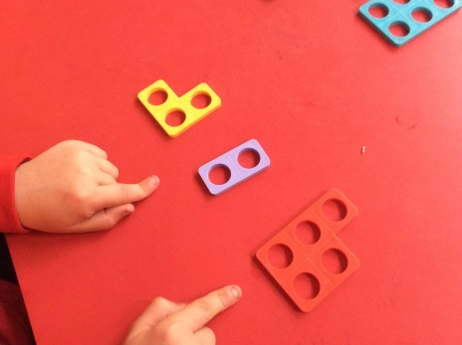

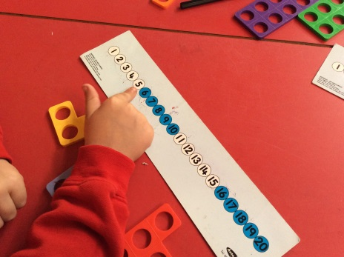
I can read a number sentence aloud in different ways.

I can use number lines to ‘jump’ along to ‘count on’.

Mental Strategies
- I can count reliably from numbers 1-20
- I can place the numbers 1-20 in order
- I can say one more or one less
- I can count on or back from a given number

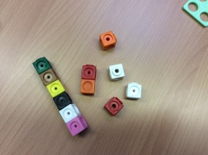
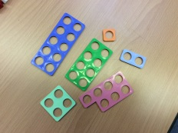
Equipment

Key Vocabulary
Add, more, plus, makes, total, altogether, score, double, one more, two more, ten more.

Example of Key Questions
How many more is… than…?
How many more to make…?

Games and songs can be a good way to begin using vocabulary involved in addition e.g. Alice the Camel

Subtraction
I can solve simple problems using fingers

I can use Numicon to take away numbers

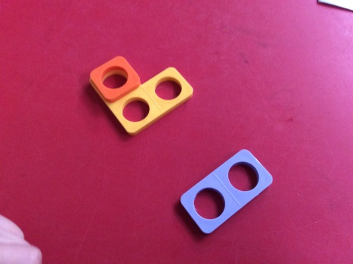

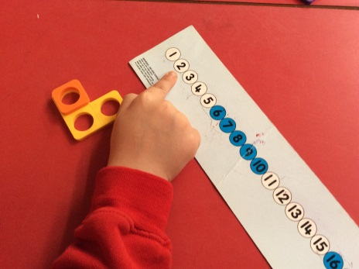
I can read a number sentence aloud in different ways.

I can use number lines to ‘jump’ back to ‘count down.

Mental Strategies
- I can count reliably from numbers 1-20
- I can place the numbers 1-20 in order
- I can say one more or one less
- I can count on or back from a given number
Equipment

Key Vocabulary
Take, take away, leave, subtract, minus, equals, count back, one less, two less, ten less.

Example of Key Questions
How many are left / left over?
How many have gone?
How many fewer is… than…?
Games and songs can be a good way to begin using vocabulary involved in subtraction e.g. Five Currant Buns, Ten Green Bottles, Five Little Men in a Flying Saucer.

Multiplication

I can use pictures to work out how many groups of or lots of I have.

I can use Numicon to show repeated addition.

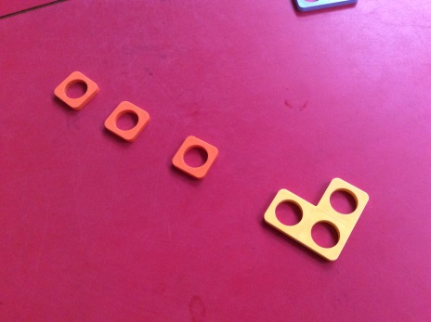

I can count in twos, fives, tens aloud and with objects.

I can read number sentences aloud and in different ways.

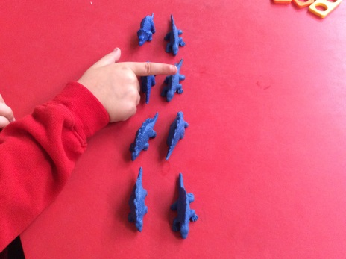

Mental Strategies
- I can count in 2’s,5’s,10’s
- I can use repeated addition
- I can solve problems involving doubling

Equipment

Key Vocabulary
Lots of, groups of, times, repeated addition, double, twos, fives, tens.

Example of Key Questions

How many groups of… are there?
How many legs on four ducks?
How many lots of… make…?

Division

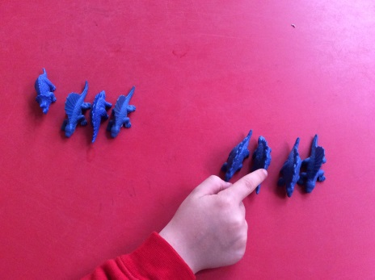
I can share or halve an equal amount into two groups

I can have a go at recording my number sentences

I can share equally by using different resources.

I can group resources equally.
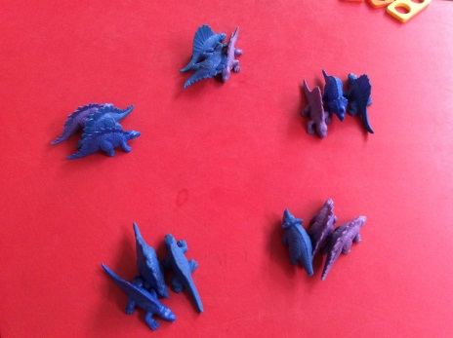

Mental Strategies
- I can count in 2’s,5’s,10’s
- I can share equally
- I can solve problems involving halving

Equipment

Key Vocabulary
Half, halve, share, share equally, one each, two each etc, group in pairs, threes, tens etc. equal groups of, left, left over

Example of Key Questions
Mum has 6 socks. She grouped them into pairs. How many pairs did she make?

