Reading at Measham CE School

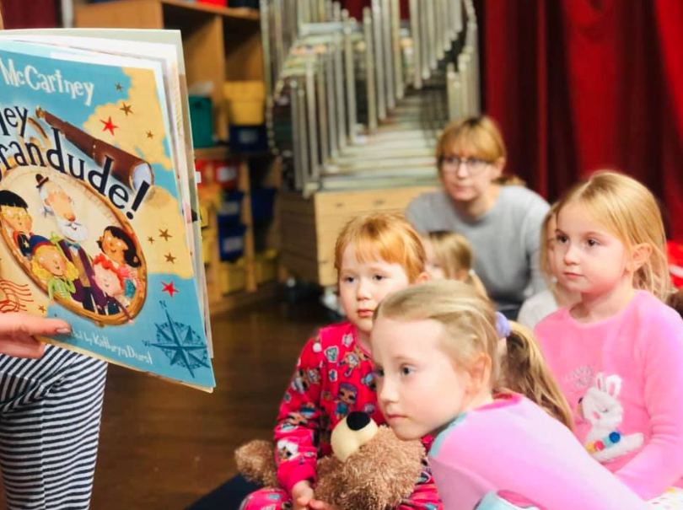

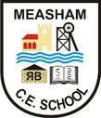
Reading at Measham CE

This document is intended to support teachers in preparing their learning environment and planning the reading work for their pupils.

Aims
This approach aims to:
- Ensure that children become a reader, a writer and a confident speaker by the time they leave Year 6
- Promote and instil a love of reading for pleasure
- Deliver a top-quality and carefully sequenced curriculum that is progressive throughout the school and fosters the acquisition or knowledge and skills
- Broaden the vocabulary of our children

At Measham CE Primary School, it is our intent to equip children with lifelong knowledge; skills and understanding that will teach children to become confident with speaking, reading and writing. We strive to ensure that all children receive a powerful introduction to English from Early Years Foundation Stage to the end of Year 6 and that this is embedded within our school culture. It is our intention to immerse pupils within our book rich curriculum to develop a lasting love of reading.

English is a core subject within the National Curriculum and it underpins educational and social progress within our daily life. The acquisition of language skills is a fundamental aspect to learning at Measham CE School and we endeavour to provide many opportunities for our young learners to succeed and develop strong language and communication skills. Confidence in language skills gives young learners the opportunity to communicate imaginatively, preparing them for success in their future journey in education and beyond.

The National Curriculum

The National Curriculum for English consists of four strands:
- Spoken Language
- Reading
- Writing
- Spelling, Vocabulary, Grammar and Punctuation

The National Curriculum allows for children to develop skills in interpreting the meaning of a whole variety of texts; children learn to pick up on implied meaning and identify writing techniques that they can apply in their writing.

Reading Scheme

Our reading scheme matches children’s knowledge of phonics. We use Sounds Write and Dandelion books with children in EYFS to match the sounds that they are learning in class. Children in Year 1 upwards read books from our colour banded scheme. Children have access to both fiction and non-fiction books for home reading.

Phonics

In 2019 we began to use Sounds Write, a synthetic phonics scheme. All members in EYFS, Key Stage 1 and some support staff in Key Stage 2 are trained in this. Sounds Write teaches children to firstly hear the sounds in the word, before writing the corresponding letter. Children are taught one-letter sounds in EYFS before learning some two-letter sounds in the Summer Term. Children in Year 1 begin to learn two and three-letter sounds and this is reinforced in Year 2, where children break down polysyllabic words to help them to read and spell.

Lexia

Lexia is a high quality reading resource that reinforces children’s independent reading skills, such as inference and deduction. The class teachers pick out a handful of children that this would benefit, focusing on any Pupil Premium children. Lexia should be carried out 3 times a week for 20 minutes, in EYFS this is 15 minutes per week.

Early Years Foundation Stage

Children in EYFS are read at least one story every day. Children are heard read by an adult at least once a week, the lowest 20% of readers are read with every day. The class teacher teaches children a specific Phonics session daily and some children work with the teaching assistants to strengthen their phonological awareness.

Key Stage 1

Fluency underpins the teaching of reading in Key Stage 1; children are taught through whole class guided reading 3 to 4 times a week. Children begin their week by exploring a text and picking our key vocabulary before answering comprehension questions on this. The teacher and teaching assistants read with children once a week. Interventions are put in place for children who need to strengthen their independent reading skills. At the end of the day, children in Year 1 enjoy their favourite stories, whilst children in Year 2 follow a longer story.

Children in Key Stage 1 benefit from daily Phonics sessions; Children in Year 1 undertake their Phonics Screening Test in June and those that do not pass form a focus group for targeted support in Year 2. Due to Covid-19 children in Year 2 are taking the Phonics Screening Test in Autumn 2020.

Lower Key Stage 2

In Lower Key Stage 2, reading is part of the English lesson and not separate, part of the Key Stage 2 book rich curriculum. Teachers choose a book to focus upon each half term, linked to their topic. All of the writing and SPaG in Year 3 and 4 are linked to their book. Every week, teachers ask comprehension questions linked to the book, in a range of question types such as inference and retrieval. At the end of the day, children enjoy a story together.

Upper Key Stage 2

In Upper Key Stage 2, reading is promoted through the Book Rich curriculum, where all of the reading and writing tasks are linked to the book that they are exploring for the half term, to really promote a love of reading. Children decode interesting and new vocabulary to pick apart the text.

Independent reading is promoted through quiet reading sessions and this is followed up to ensure that reading happens at home too. Year 6 complete various reading interventions such as Comprehension Ninja to look at skills, skimming and scanning. Short pieces of text are also explored in preparation for the SATs in May.

SEN and Equal Opportunities

Those children who are identified as needing extra support are monitored closely by the class teacher and the SENCo. Specific interventions are put in place to support those children. These children are tracked using our Small Steps tracker.

Classrooms

All classrooms have a class reading area with books that are well organised and easily accessible. The books are age appropriate and have a selection of fiction and non-fiction. A selection of topic books are also available for the children to access to enhance their learning.

The Role of Volunteers

At Measham CE we welcome volunteers who have some time to come into school and hear our readers. The volunteer is allocated to a class and the class teacher selects children who would benefit from the extra reading to an adult. Due to Covid-19 we are limiting the amount of adults in school and volunteers will be welcomed at a later date.

Working in Partnership with Parents

The teaching of reading is greatly helped by a strong communication and support from parents. Parents with children in EYFS are invited to a Phonics Parents Meeting at the start of the year where the EYFS teacher will model how we teach reading and Phonics at Measham. Parents are encouraged to monitor children’s reading through reading 3-4 times a week with their child at home and signing their reading record.

Library

Our library is a cosy, comfy and welcoming space in our school. Each class has an allocated time when groups can visit the library and take out a book to take home or have access to the library trolley.

World Book Day

To further engage a love of reading, we celebrate World Book Day with the children each year, taking the opportunity to promote a love of books and reading.

